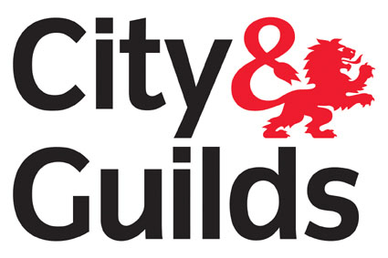

Level 2 Certificate in Health and Safety in the Workplace
Qualification No: 4065-02 Accreditation No: 600/4150/X
Who is this qualification for?

The Certificate is ideal for those who are looking to gain more knowledge of particular aspects of Health and Safety.

It is aimed at those with no formal training in health and safety, and could be used for those looking to return to work.
Qualification Structure

To achieve the Level 2 Certificate in Health and Safety in the Workplace, learners must achieve 4 credits from the mandatory units and a minimum of 10 credits from the optional units available.
Guided Learning Hours: 85 – 105

Unit No | Unit Title | Credit Value
Mandatory
101 | Fire Safety Awareness | 1
201 | Health and Safety in the Workplace | 1
203 | Risk Assessment | 2
Optional
202 | Fire Safety Principles | 1
208 | Fundamentals of Display Screen Equipment | 2
210 | Manual Handling Safety at Work | 2
211 | Moving People Safely | 2
112 | Internet Safety for IT users | 3

What does this qualification cover?

This qualification was developed to provide candidates with a general qualification in Health and Safety for the Workplace.

The development was prompted by a demand for a generic health and safety qualification at Level 2, rather than qualifications designed for use in specific sectors, as this would have the widest appeal to employers.

Entry requirements?

There are no formal entry requirements or age restrictions for candidates undertaking this qualification.

Progression routes?

A Certificate in Health and Safety in the Workplace provides more knowledge of particular aspects of Health and Safety. It would allow you to progress to the following qualification:
- Level 3 NVQ Certificate in Occupational Health and Safety (QCF)
- Level 5 NVQ Diploma in Occupational Health and Safety Practice (QCF)

Safety Advisory Services Ltd is an Approved City and Guilds Provider, Centre No: 722250.

Find us at: 1 Cranham Court, Arden Square, Crewe Business Park, Crewe, CW1 6HA (UK).

Call on: +44 (0)1270 584552
Email us: services@sas-ltd.co.uk
Web: www.sas-ltd.co.uk

Ref: /tmp/in/input.doc

